**ECSE 597 Assignment 2 Report**

**TestDCsolve.m**

Figure 1 shows the implementation of dcsolve.m, and results of TestDCsolve.m are shown in Figure 2.

Figure - TestDCsolve.m Results

Figure - dcsolve Implementation

**BJT_CB.m**

The implementation of dcsolvealpha.m and dcsolvecont.m are shown in Figure 5 and 6. The results of BJT_CB.m are shown in Figure 3 and 4. The dcsolve.m implemented previously does not guarantee convergence, as shown in Figure 3. In contrast, the dcsolvecont.m converges, and the results are shown in Figure 4.

Figure - BJT_CB.m DCSolve Result

Figure - BJT_CB.m DCsolve_cont Result

Figure - dcsolvealpha.m Implementation

Figure - dcsolvecont.m Implementation

**BJT_CE2.m**

The results of DC analysis of BJT_CE2.m are shown in Figure 7 and 8. The dcsolve.m does not converge whereas the dcsolvecont.m converges. The implementation of nonlinear_fsolve.m is shown in Figure 9, and the results is shown in Figure 10.

Figure - BJT_CE2 dcsolve Result

Figure - BJT-CE2 decolvecont Result

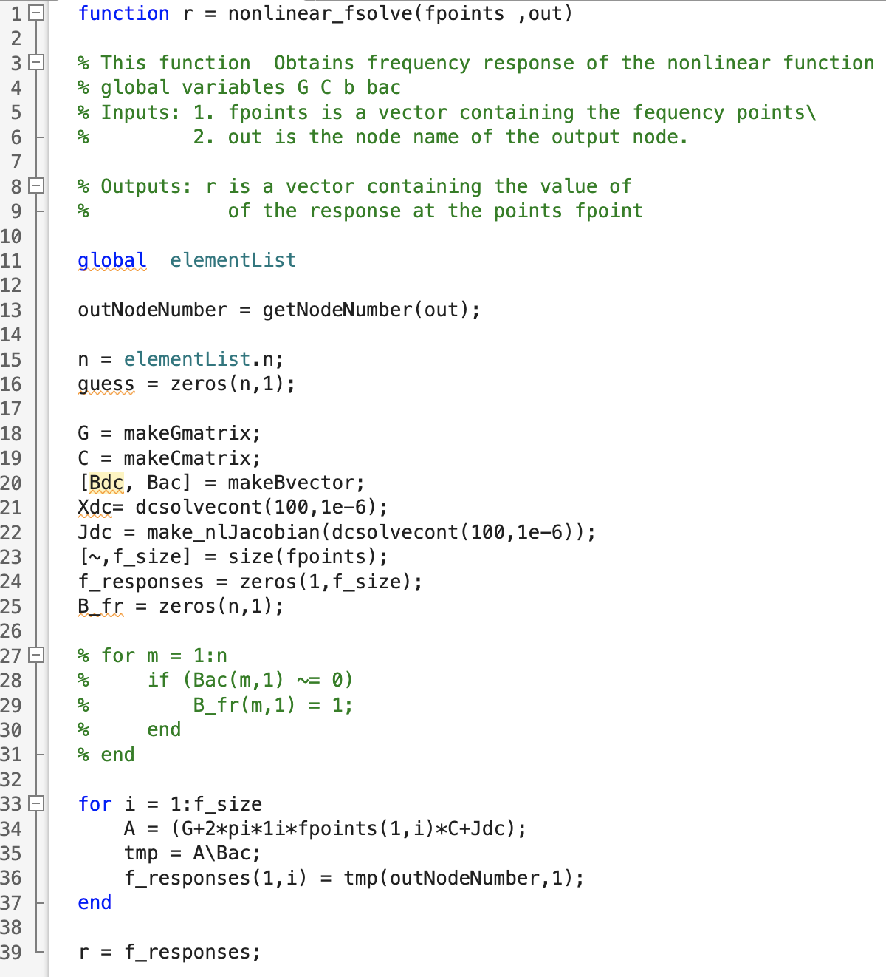

Figure - nonlinear_fsolve Implementation

Figure - Frequency Analysis of BJT_CE2